**Before testing:**

1. Download the UAT.zip from
2. Unzip the folder to your desktop (or anywhere you will remember it)
   1. If you cannot unzip the zipped folder, right click it -> Send to… -> Compressed (zipped) folder
3. Open UAT folder, and ensure the Thonny Logo is the icon for each Python file (shown below)



* 1. If the Thonny logo is not on your python file, complete the following steps:
     1. Right click any python file -> Open with -> Choose another app
     2. If Thonny is not one of the listed apps, scroll down and click “Look for another app on this PC”
     3. Search for Thonny and use that
     4. The python file will then open in Thonny
     5. Exit out of the file, then repeat step 3.a.i
     6. Choose Thonny as the app, and check the box “Always use this app to open .py files”
     7. Continue to step 4

1. Copy and open the autograder.py file
2. With Thonny open, click Tools -> Manage packages… -> cs110 -> Click the “Installed to” link

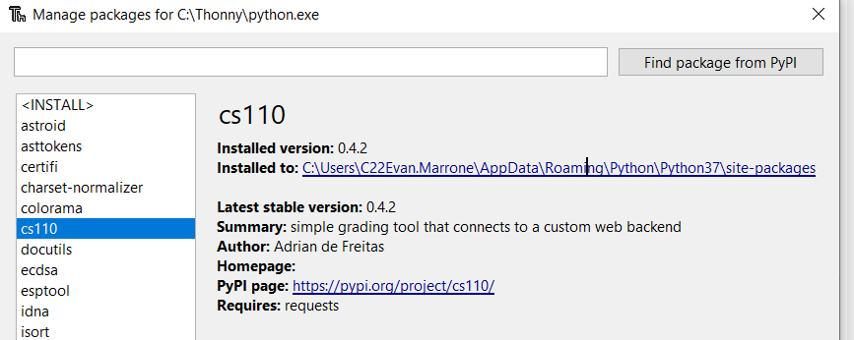

1. Go into the cs110 folder -> paste the copied autograder.py file -> replace file in destination
2. Exit out of everything except UAT folder

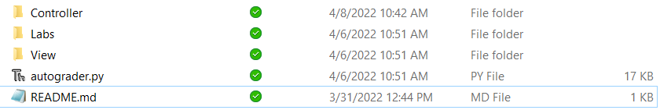

1. Double click Controller -> Double click UAT.exe
2. Set up screen as below, then solve problems based on what the tutor recommends:

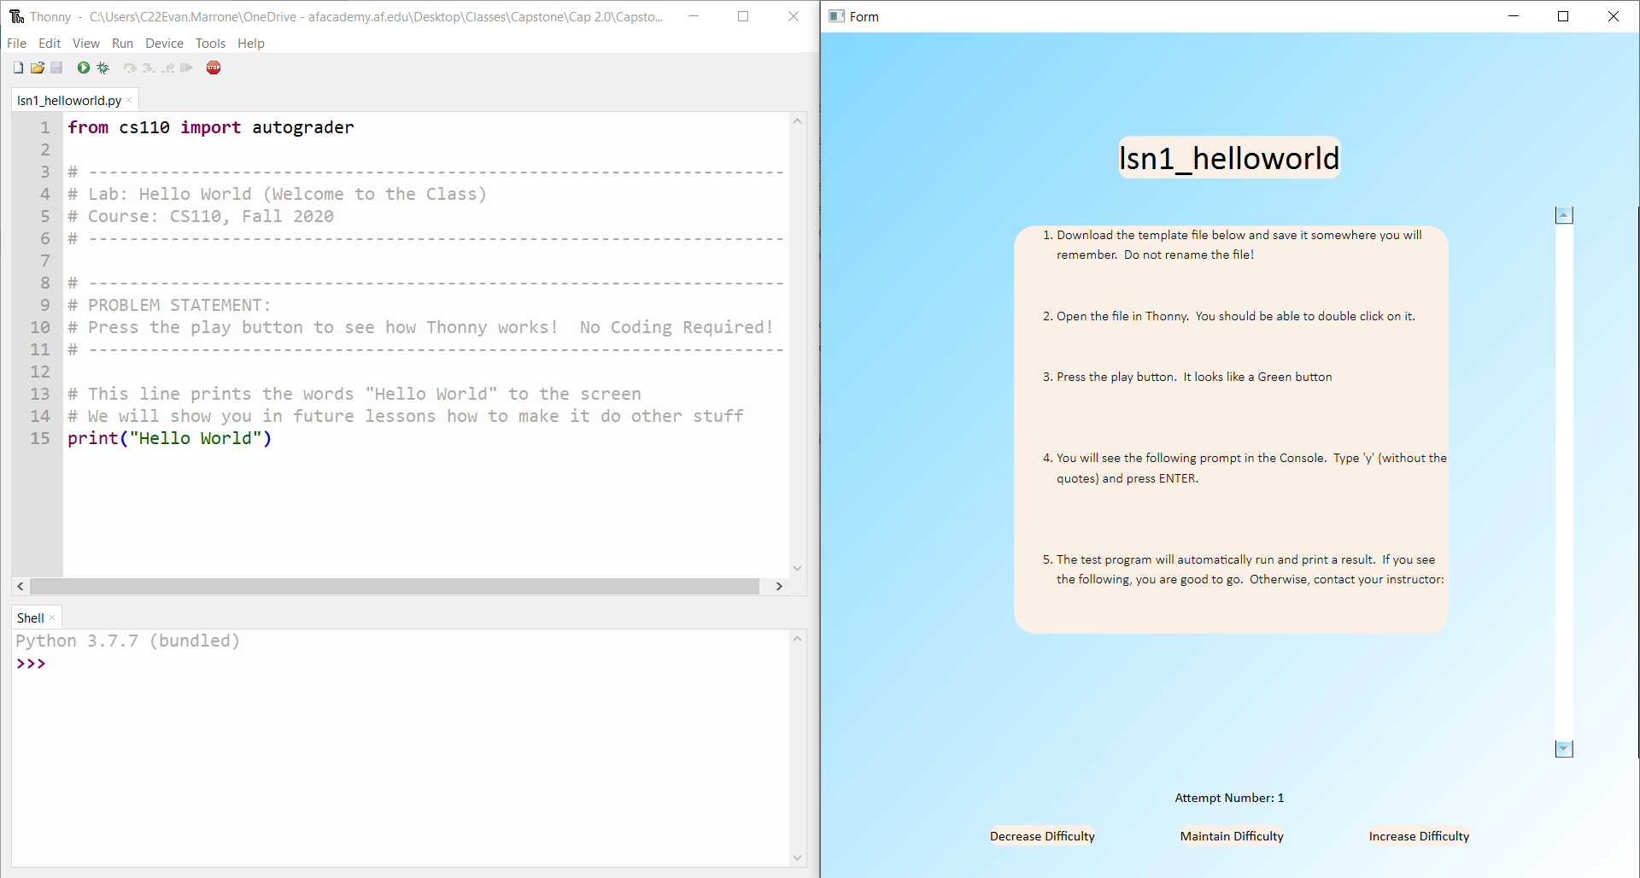

**After testing:**

1. Once complete, uninstall cs110 and then reinstall it

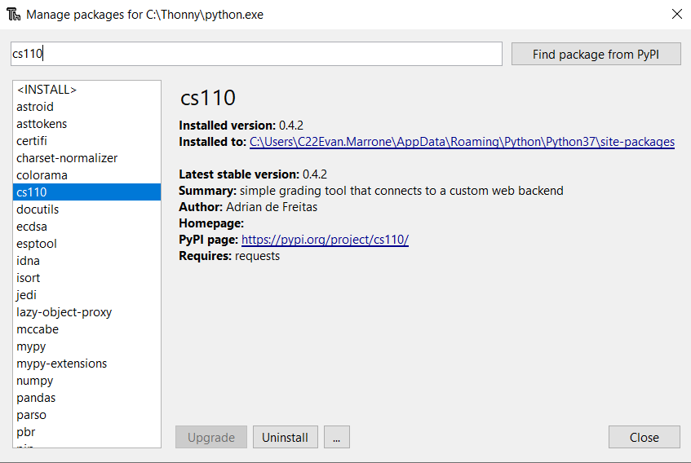

1. You are now finished